# About

This walkthrough will guide you in order to use the UMA’s iPerf Android application.

# iPerf Application

This application acts as a wrapper for the iPerf measuring tool. This application allows the usage of iPerf on Android terminals remotelly, thus enabling the usage of Android terminals in automated performance test. Additionally, the application can be used directly from the user interface.

# Usage

The application can be used on the terminal with the provided user interface, or remotely through adb commands.

## Adb commands

The application can be used remotely sending intents to the service via the startservice command of adb:

adb shell am startservice -n com.uma.iperf/.iPerfService

The application accepts the following intents (-a):

com.uma.iperf.CLIENTSTART ***(Requires parameters)***

com.uma.iperf.SERVERSTART ***(Requires parameters)***

com.uma.iperf.CLIENTSTOP

com.uma.iperf.SERVERSTOP

Parameters sent to the iPerf binary are passed as a comma separated string (with no spaces) using the intent extra (-e) com.uma.iperf.PARAMETERS.

In some cases, it is necessary to specify the user of the command with --user 0, this flag does not seem to have any adverse effect, so it is recommended to use it always.

**EXAMPLES**

adb shell am startservice -n com.uma.iperf/.iPerfService -a com.uma.iperf.CLIENTSTOP

adb shell am startservice -n com.uma.iperf/.iPerfService -a com.uma.iperf.CLIENTSTART -e com.uma.iperf.PARAMETERS "-c,127.0.0.1,-t,35,-w,4000K,-p,5002,-l,1470,-f,m,-P,1,-i,1" --user 0

## Device Interface

The application can be used through the device interface. The application is divided into two parts, one for using iPerf as a server mode and the other one for using it as a client. Both parts are configured pressing the button Parameters *(1)* and executed pressing the button Start *(2)*.

Once any of the iPerf modes are initiated, its corresponding Log *(3)* will be updated during the execution.

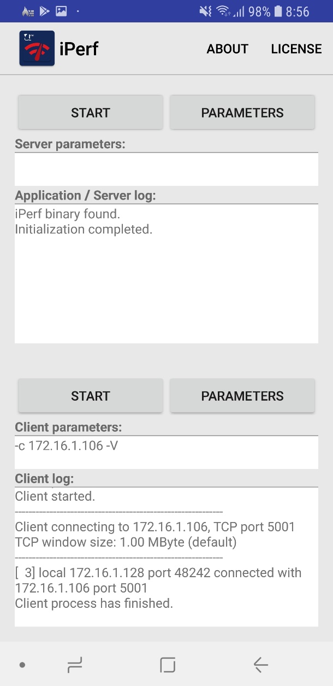

**3**

**3**

**2**

**2**

**1**

**1**

Figure 1: Application Interface